AI ASSISTED CODING
Name:G.Gouri Shankar
Hall Ticket NO:2303A51012
Batch-01
Problem 1: Syntax and Logic Errors
Use AI to identify and fix syntax and logic errors in a faulty Python script.
Sample Input:
# Calculate average score of a student
def calc_average(marks):
total = 0
for m in marks:
total += m
average = total / len(marks)
return avrage # Typo here
marks = [85, 90, 78, 92]
print("Average Score is ", calc_average(marks)
Expected Output:
- Corrected and runnable Python code with explanations of the Fixes.
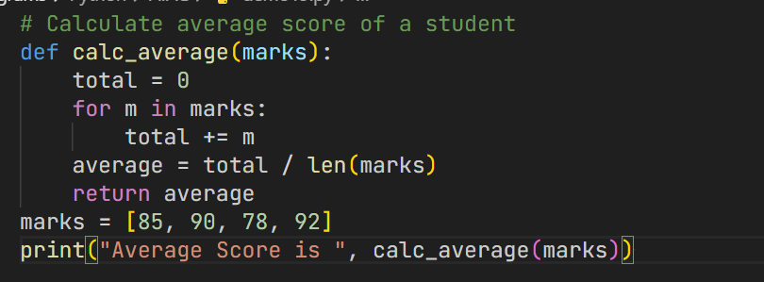
Problem 2: PEP 8 Compliance
Use AI to refactor Python code to follow PEP 8 style guidelines.
Sample Input:
def area_of_rect(L,B) : return L*B
print(area_of_rect(10,20))
Expected Output:
- Well-formatted PEP 8-compliant Python code
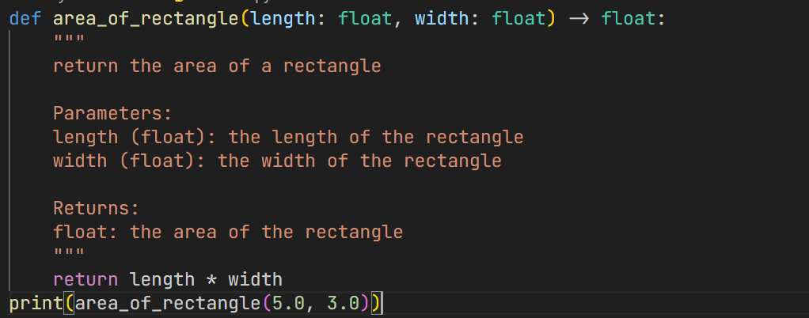
Problem 3: Readability Enhancement
Use AI to make code more readable without changing its logic.
Sample Input:
def c(x,y):
return x*y/100
a=200
b=15
print(c(a,b))
Expected Output:
- Python code with descriptive variable names, inline comments, and clear formatting.
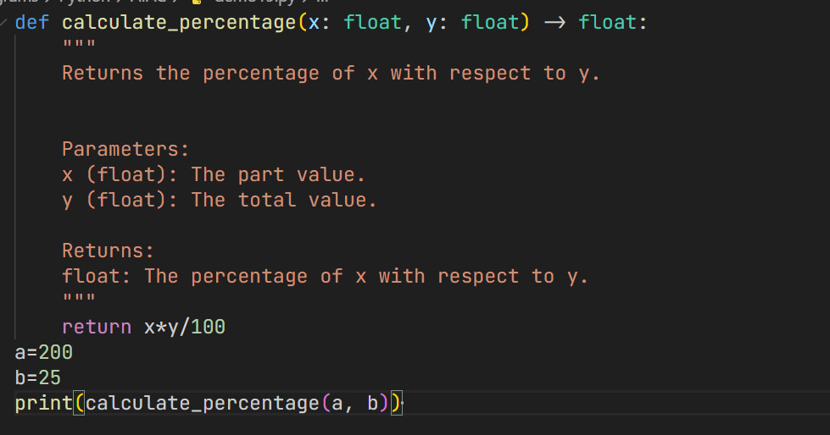

Problem 4: Refactoring for Maintainability
Use AI to break repetitive or long code into reusable functions
Sample Input:
students = ["Alice", "Bob", "Charlie"]
print("Welcome", students[0])
print("Welcome", students[1])
print("Welcome", students[2])
Expected Output:
- Modular code with reusable functions.
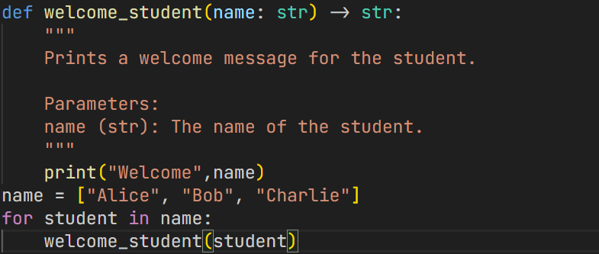
Problem 5: Performance Optimization
Use AI to make the code run faster
Sample Input:
# Find squares of numbers
nums = [i for i in range(1,1000000)]
squares = []
for n in nums:
squares.append(n**2)
print(len(squares))
Expected Output:
- Optimized code using list comprehensions or vectorized operations.
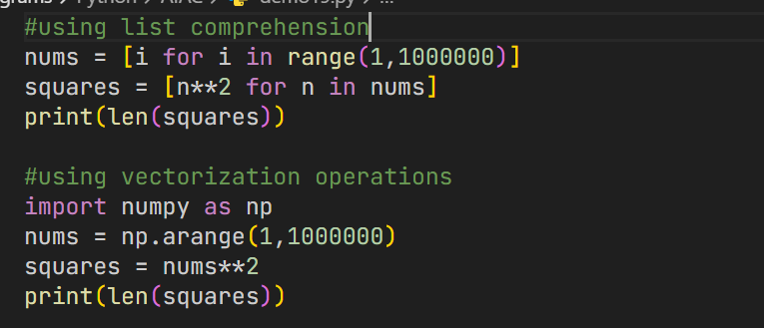
Problem 6: Complexity Reduction
Use AI to simplify overly complex logic.
Sample Input:
def grade(score):
if score >= 90:
return "A"
else:
if score >= 80:
return "B"
else:
if score >= 70:
return "C"
else:
if score >= 60:
return "D"
else:
return "F"
Expected Output:
- Cleaner logic using elif or dictionary mapping.
